**Rajan Gautam**

**19BCP101**

**Div. II, CE 19**

**SOT, PDEU**

**Pandit Deendayal Energy University**

**School of Technology**

**Design & Analysis of Algorithm (20CP209P)**

**B. Tech - Computer Science & Engineering (Sem-IV)**

**Table of Contents**

**Lab 3 Assignment: Implementation of Greedy Algorithm 2**

**AIM 1: To write a C/C++ Program to implement Greedy Algorithm for given problem. 2**

**ALGORITHMS: 2**

**CODE: 3**

**OUTPUT: 4**

**AIM 2: To Implement Greedy Algorithm for computing Minimum Spanning Tree using Kruskal Algorithm. 5**

**Kruskal Algorithm: 5**

**CODE: 5**

**OUTPUT: 10**

**AIM 3: To solve the given problem. 10**

**CODE: 11**

**OUTPUT 1: 11**

**OUTPUT 2: 13**

# Lab 3 Assignment: Implementation of Greedy Algorithm

## AIM 1: To write a C/C++ Program to implement Greedy Algorithm for given problem.

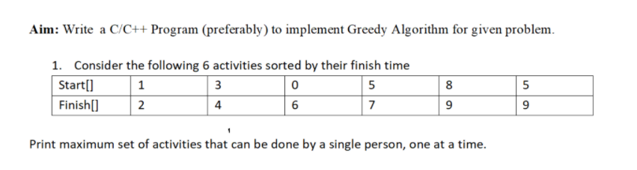

### ALGORITHMS:

#### Insertion Sort Algorithm (Pseudocode)

**INSERTION-SORT (A, n)**

**for j 🡨 2 to n**

**Do key 🡨 A[j]**

**i 🡨 j – 1**

**while i > 0 and A[i] > key**

**Do A [i + 1] 🡨 A[i]**

**i 🡨 i – 1**

**A [i + 1] = key**

#### Greedy Algorithm

**Sort input activities in order by increasing finishing time.**

**n 🡨 length[s]**

**A 🡨 1**

**j 🡨 1**

**for I 🡨 2 to n**

**if si ≥ fj then**

**A 🡨 A ∪ (i)**

**j 🡨 i**

**return A**

### CODE:

1. **#include <stdio.h>**
2. **#include <stdlib.h>**
4. **// Algorithm to sort array**
5. **void insertion_sort(int A[], int n)**
6. **{**
7. **int i, j, key;**
8. **for(i = 1; i < n; i++)**
9. **{**
10. **key = A[i];**
11. **j = i - 1;**
12. **while (j >= 0 && A[j] > key)**
13. **{**
15. **A[j+1] = A[j];**
16. **j = j -1;**
17. **}**
18. **A[j+1] = key;**
19. **}**
20. **}**
22. **// Algorithm for Greedy**
23. **int GreedyAlgorithm(int S[], int F[], int n)**
24. **{**
25. **int A = 1;**
26. **int j = 1;**
27. **for (int i = 2; i <= n; i++)**
28. **{**
29. **if(S[i] >= F[j])**
30. **{**
31. **A++;**
32. **j = i;**
33. **}**
34. **}**
35. **return A;**
36. **}**
38. **// Main Function**
39. **int main()**
40. **{**
41. **// Scanning the total number of Activities**
42. **int numActivity;**
43. **printf("Enter total number of Activity: ");**
44. **scanf("%d", &numActivity);**
46. **// Declaring two arrays**
47. **int start[numActivity];**
48. **int finish[numActivity];**
50. **// Getting the values of start Array**
51. **printf("Enter starting time for %d Activities \n", numActivity);**
53. **for (int i = 0; i < numActivity; i++)**
54. **{**
55. **scanf("%d", &start[i]);**
56. **}**
58. **// Getting the values for final Array**
59. **printf("Enter finishing time for %d Activities \n", numActivity);**
61. **for (int i = 0; i < numActivity; i++)**
62. **{**
63. **scanf("%d", &finish[i]);**
64. **}**
66. **// Sorting the finish array using Insertion Sort Algorithm**
67. **insertion_sort(finish, numActivity);**
69. **// Getting the maximum set of activities that can be done by a single person**
70. **int maxNum = GreedyAlgorithm(start, finish, numActivity);**
72. **// Printing maximum number returned by our GreedyAlgorithm Function**
73. **printf("Maximum Set of Activities that can be done by a single person: %d\n", maxNum);**
75. **return 0;**
76. **}**

## OUTPUT:

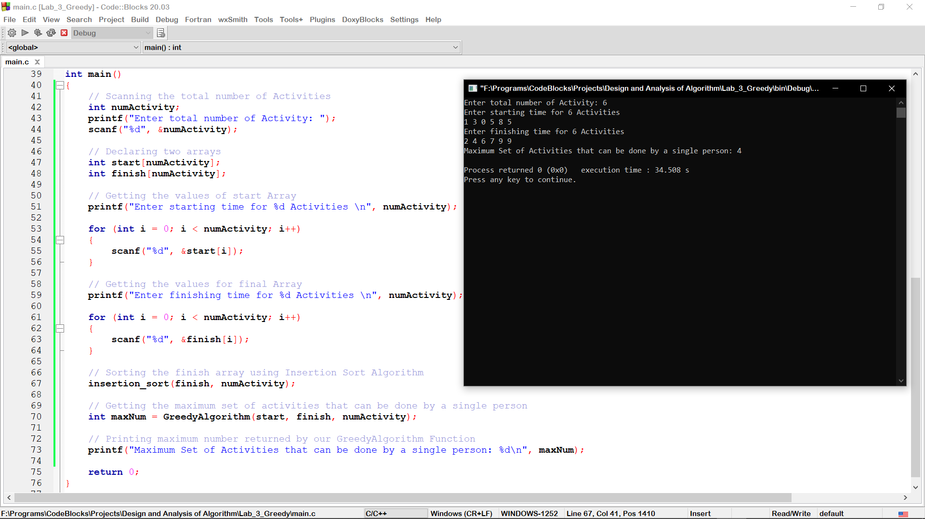

## AIM 2: To Implement Greedy Algorithm for computing Minimum Spanning Tree using Kruskal Algorithm.

## Kruskal Algorithm:

**KRUSKAL(G):**

**A = ∅**

**For each vertex v ∈ G.V:**

**MAKE-SET(v)**

**For each edge (u, v) ∈ G.E ordered by increasing order by weight (u, v):**

**if FIND-SET(u) ≠ FIND-SET(v):**

**A = A ∪ {(u, v)}**

**UNION (u, v)**

**return A for j 🡨 2 to n**

**Do key 🡨 A[j]**

**i 🡨 j – 1**

**while i > 0 and A[i] > key**

**Do A [i + 1] 🡨 A[i]**

**i 🡨 i – 1**

**A [i + 1] = key**

### CODE:

1. **#include <stdio.h>**
2. **#define MAX 30**
4. **typedef struct edge**
5. **{**
6. **int u, v, w;**
7. **} edge;**
9. **typedef struct edge_list**
10. **{**
11. **edge data[MAX];**
12. **int n;**
13. **} edge_list;**
15. **edge_list elist;**
17. **int Graph[MAX][MAX], n;**
18. **edge_list spanlist;**
20. **void kruskalAlgo();**
21. **int find(int belongs[], int vertexno);**
22. **void applyUnion(int belongs[], int c1, int c2);**
23. **void sort();**
24. **void print();**
26. **// Applying Krushkal Algo**
27. **void kruskalAlgo()**
28. **{**
29. **int belongs[MAX], i, j, cno1, cno2;**
30. **elist.n = 0;**
32. **for (i = 1; i < n; i++)**
33. **for (j = 0; j < i; j++)**
34. **{**
35. **if (Graph[i][j] != 0)**
36. **{**
37. **elist.data[elist.n].u = i;**
38. **elist.data[elist.n].v = j;**
39. **elist.data[elist.n].w = Graph[i][j];**
40. **elist.n++;**
41. **}**
42. **}**
44. **sort();**
46. **for (i = 0; i < n; i++)**
47. **belongs[i] = i;**
49. **spanlist.n = 0;**
51. **for (i = 0; i < elist.n; i++)**
52. **{**
53. **cno1 = find(belongs, elist.data[i].u);**
54. **cno2 = find(belongs, elist.data[i].v);**
56. **if (cno1 != cno2)**
57. **{**
58. **spanlist.data[spanlist.n] = elist.data[i];**
59. **spanlist.n = spanlist.n + 1;**
60. **applyUnion(belongs, cno1, cno2);**
61. **}**
62. **}**
63. **}**
65. **int find(int belongs[], int vertexno)**
66. **{**
67. **return (belongs[vertexno]);**
68. **}**
70. **void applyUnion(int belongs[], int c1, int c2)**
71. **{**
72. **int i;**
74. **for (i = 0; i < n; i++)**
75. **if (belongs[i] == c2)**
76. **belongs[i] = c1;**
77. **}**
79. **// Sorting algo**
80. **void sort()**
81. **{**
82. **int i, j;**
83. **edge temp;**
85. **for (i = 1; i < elist.n; i++)**
86. **for (j = 0; j < elist.n - 1; j++)**
87. **if (elist.data[j].w > elist.data[j + 1].w)**
88. **{**
89. **temp = elist.data[j];**
90. **elist.data[j] = elist.data[j + 1];**
91. **elist.data[j + 1] = temp;**
92. **}**
93. **}**
95. **// Printing the result**
96. **void print()**
97. **{**
98. **int i, cost = 0;**
99. **printf("Minimum Spanning Tree's Edges are: \n\n");**
100. **for (i = 0; i < spanlist.n; i++)**
101. **{**
102. **printf("%d. Edge (%d , %d) : %d\n", i+1, spanlist.data[i].u, spanlist.data[i].v, spanlist.data[i].w);**
103. **cost = cost + spanlist.data[i].w;**
104. **}**
106. **printf("\n\nMinimum Spanning Tree Cost: %d\n\n", cost);**
107. **}**
109. **int main()**
110. **{**
111. **n = 9;**
113. **Graph[0][0] = 0;**
114. **Graph[0][1] = 4;**
115. **Graph[0][2] = 0;**
116. **Graph[0][3] = 0;**
117. **Graph[0][4] = 0;**
118. **Graph[0][5] = 0;**
119. **Graph[0][6] = 0;**
120. **Graph[0][7] = 8;**
121. **Graph[0][8] = 0;**

124. **Graph[1][0] = 4;**
125. **Graph[1][1] = 0;**
126. **Graph[1][2] = 8;**
127. **Graph[1][3] = 0;**
128. **Graph[1][4] = 0;**
129. **Graph[1][5] = 0;**
130. **Graph[1][6] = 0;**
131. **Graph[1][7] = 11;**
132. **Graph[1][8] = 0;**

135. **Graph[2][0] = 0;**
136. **Graph[2][1] = 8;**
137. **Graph[2][2] = 0;**
138. **Graph[2][3] = 7;**
139. **Graph[2][4] = 0;**
140. **Graph[2][5] = 4;**
141. **Graph[2][6] = 0;**
142. **Graph[2][7] = 0;**
143. **Graph[2][8] = 2;**

146. **Graph[3][0] = 0;**
147. **Graph[3][1] = 0;**
148. **Graph[3][2] = 7;**
149. **Graph[3][3] = 0;**
150. **Graph[3][4] = 9;**
151. **Graph[3][5] = 14;**
152. **Graph[3][6] = 0;**
153. **Graph[3][7] = 0;**
154. **Graph[3][8] = 0;**

157. **Graph[4][0] = 0;**
158. **Graph[4][1] = 0;**
159. **Graph[4][2] = 0;**
160. **Graph[4][3] = 9;**
161. **Graph[4][4] = 0;**
162. **Graph[4][5] = 10;**
163. **Graph[4][6] = 0;**
164. **Graph[4][7] = 0;**
165. **Graph[4][8] = 0;**

168. **Graph[5][0] = 0;**
169. **Graph[5][1] = 0;**
170. **Graph[5][2] = 4;**
171. **Graph[5][3] = 14;**
172. **Graph[5][4] = 10;**
173. **Graph[5][5] = 0;**
174. **Graph[5][6] = 2;**
175. **Graph[5][7] = 0;**
176. **Graph[5][8] = 0;**

179. **Graph[6][0] = 0;**
180. **Graph[6][1] = 0;**
181. **Graph[6][2] = 0;**
182. **Graph[6][3] = 0;**
183. **Graph[6][4] = 0;**
184. **Graph[6][5] = 2;**
185. **Graph[6][6] = 0;**
186. **Graph[6][7] = 1;**
187. **Graph[6][8] = 6;**

190. **Graph[7][0] = 8;**
191. **Graph[7][1] = 11;**
192. **Graph[7][2] = 0;**
193. **Graph[7][3] = 0;**
194. **Graph[7][4] = 0;**
195. **Graph[7][5] = 1;**
196. **Graph[7][6] = 0;**
197. **Graph[7][7] = 0;**
198. **Graph[7][8] = 7;**

201. **Graph[8][0] = 0;**
202. **Graph[8][1] = 0;**
203. **Graph[8][2] = 2;**
204. **Graph[8][3] = 0;**
205. **Graph[8][4] = 0;**
206. **Graph[8][5] = 0;**
207. **Graph[8][6] = 6;**
208. **Graph[8][7] = 7;**
209. **Graph[8][8] = 0;**

212. **kruskalAlgo();**
213. **print();**
214. **}**
215. **Print the number of edges and total cost of Minimum Spanning Tree.**

### OUTPUT:

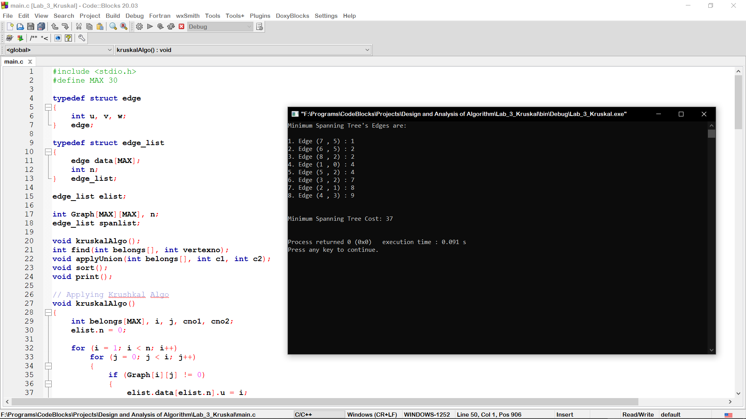

1. **Analyze the time complexity of your algorithm.**

* The Time Complexity of Kruskal Algorithm is O (E log E).

## AIM 3: To solve the given problem.

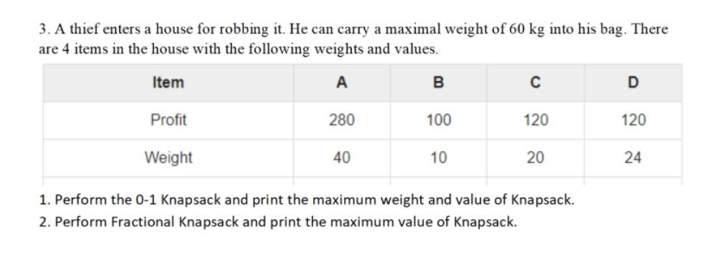

1. **Perform the 0-1 Knapsack and print the maximum weight and value of Knapsack.**

### CODE:

1. **#include <bits/stdc++.h>**
2. **using namespace std;**
3. **int max(int a, int b)**
4. **{**
5. **return (a > b) ? a : b;**
6. **}**
7. **int knapSack(int W, vector<int>wt, vector<int>val, int n)**
8. **{**
9. **if (n == 0 || W == 0)**
10. **return 0;**
11. **if (wt[n - 1] > W)**
12. **return knapSack(W, wt, val, n - 1);**
13. **else**
14. **return max(val[n - 1] + knapSack(W - wt[n - 1], wt, val, n - 1), knapSack(W, wt, val, n - 1));**
15. **}**
16. **// Driver code**
17. **int main()**
18. **{**
19. **vector<int> profit= {280,100,120,120};**
20. **vector<int> weight= {40,10,20,24};**
21. **int W = 60;**
22. **int n = profit.size();**
23. **cout<<"Maximum Value of Knapsack is " << knapSack(W, weight, profit, n)<<endl;**
24. **return 0;**
25. **}**

### OUTPUT 1:

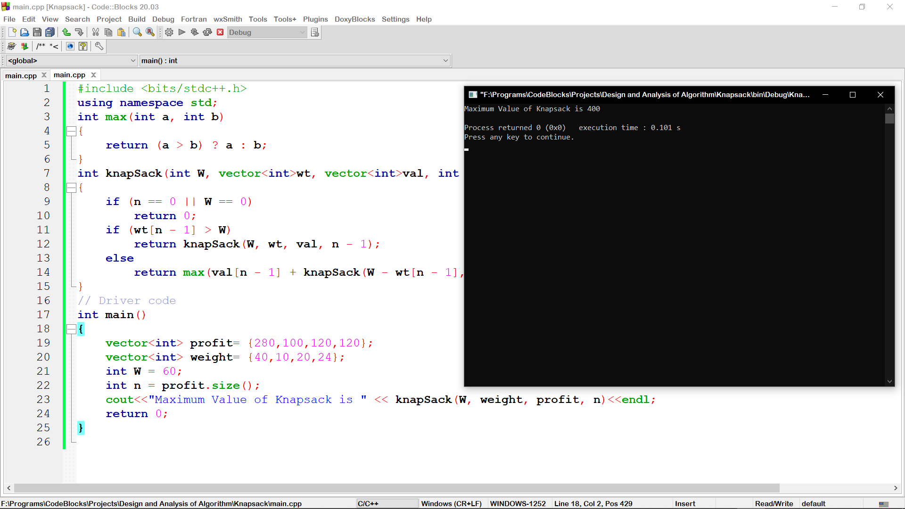

1. **Perform Fractional Knapsack and print the maximum value of Knapsack.**
2. **#include<bits/stdc++.h>**
3. **using namespace std;**
4. **struct Item**
5. **{**
6. **int profit;**
7. **int weight;**
9. **};**
10. **bool comp(Item a,Item b)**
11. **{**
12. **double i1 = (double)a.profit/double(a.weight);**
13. **double i2 = (double)b.profit/double(b.weight);**
14. **return i1>i2;**
15. **}**
16. **double fractionalKnapsack(int W,Item arr[],int n)**
17. **{**
19. **sort(arr,arr+n,comp);**

22. **int currentWeight=0;**
23. **double finalProfit=0.0;**
25. **for(int i=0; i<n; i++)**
26. **{**
27. **if(currentWeight+arr[i].weight<=W)**
28. **{**
29. **currentWeight+=arr[i].weight;**
30. **finalProfit+=arr[i].profit;**
31. **}**
32. **else**
33. **{**
34. **int remaining=W-currentWeight;**
35. **finalProfit+=(arr[i].profit*((double)remaining)/(double)arr[i].weight);**
37. **break;**
38. **}**
39. **}**
41. **return finalProfit;**
43. **}**
44. **int main()**
45. **{**
47. **int W=60;**
48. **int n=4;**
49. **Item arr[4]= {{280,40},{100,10},{120,20},{120,24}};**
50. **cout<< "Maximum Value of Knapsack is " <<fractionalKnapsack(W,arr,n) <<endl;**
51. **return 0;**
52. **}**

### OUTPUT 2:

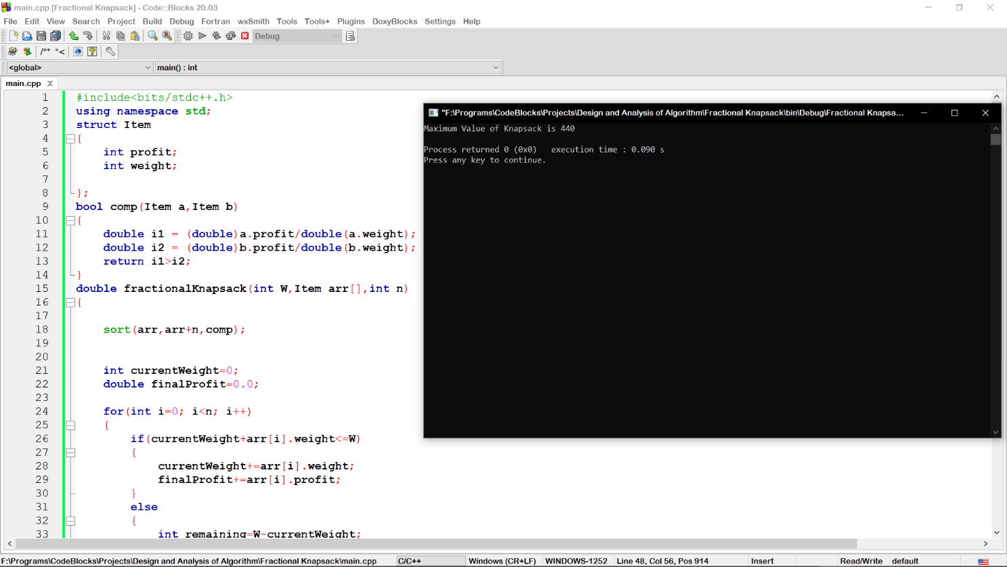

**Link:** <https://github.com/rgautam320/Design-and-Analysis-of-Algorithm-Lab/tree/master/Lab_3_Greedy>